**PERSONAL PORTFOLIO**

**A PROJECT REPORT**

***Submitted by***

**PRATEEK SINGH**

***in partial fulfillment for the award of the degree***

***of***

**BACHELOR OF TECHNOLOGY**

**IN**

**COMPUTER SCIENCE AND ENGINEERING**



**Lovely Professional University, Punjab**

**NOVEMBER, 2024**

**ABSTRACT:**

This is to verify that project entitled “Personal Portfolio Website” which is submitted by me in partial fulfillment of the requirement for the award of degree B. Tech in Computer Science and Engineering to LOVELY PROFESSIONAL INSTITUTE , Phagwara , Punjab comprise only my original work and due acknowledgement has been in the text to all other material used.

**DATE : 05/11/2024 NAME OF STUDENT : PRATEEK SINGH**

Lovely Professional University, Punjab

BONAFIDE CERTIFICATE

Certified that this project report “…….PERSONAL PORTFOLIO………” is the bonafide work of “…………..PRATEEK SINGH.…………...” who carried out the project work under my supervision.

SIGNATURE

Dr. Manjot Kaur

CHAPTER 1: INTRODUCTION AND PROJECT OBJECTIVE

### Introduction:

A personal portfolio is an essential tool for showcasing your skills, experience, and accomplishments in a professional and visually appealing manner. It serves as a digital resume, offering potential employers, clients, or collaborators a comprehensive overview of your work, achievements, and personality. Whether you're a developer, designer, writer, or any other professional, having an online portfolio allows you to demonstrate your expertise and passion.

**Project Objective:**

The objective of this personal portfolio project is to create a visually engaging and user-friendly website that highlights my skills, experience, and key projects. It aims to provide a seamless navigation experience, with sections dedicated to my bio, work samples, and contact details. The portfolio will be responsive and accessible across various devices, ensuring that it reaches a broad audience. Additionally, the project will reflect my unique style and approach to problem-solving, while emphasizing my proficiency in web development and design principles.

CHAPTER 2: CONCLUSION AND FUTURE DIRECTIONS

### Conclusion:

In conclusion, the personal portfolio serves as a powerful tool to present one's professional identity, skills, and accomplishments in a clear and engaging way. By combining well-structured content, a user-friendly design, and responsive features, it creates an impactful first impression for potential employers, clients, and collaborators. This project not only showcases my technical abilities in web development but also reflects my creativity and attention to detail. A well-crafted portfolio is an ongoing representation of growth and achievements, continuously updated as I acquire new skills and complete new projects. Ultimately, the personal portfolio is a dynamic online presence that opens doors to professional opportunities and networking.

CODE SNIPPET:

<!DOCTYPE html>

<html>

    <head>

        <style>

        @import url('https://fonts.googleapis.com/css2?family=Poppins:ital,wght@0,100;0,200;0,300;0,400;0,500;0,600;0,700;0,800;0,900;1,100;1,200;1,300;1,400;1,500;1,600;1,700;1,800;1,900&display=swap');

:root{

    --primary-color: #a855f7;

    --primary-color-dark: #9333ea;

    --secondary-color: #ca8a04;

    --text-dark: #1f2937;

    --text-light: #6b7280;

    --extra-light: #faf5ff;

    --max-width: 1200px;

}

*{

    padding: 0;

    margin: 0;

    box-sizing: border-box;

}

a{

    text-decoration: rgb(222, 182, 130);

}

body{

    font-family: "Poppins", sans-serif;

}

nav{

    width: 100%;

    position: fixed;

    top: 0;

    left: 0;

    background-color: #c6e2d9e0;

    z-index: 99;

}

.nav__content{

    max-width: var(--max-width);

    margin: auto;

    padding: 1.5rem 1rem;

    display: flex;

    align-items: center;

    justify-content: space-between;

}

nav .logo a{

    font-size: 1.5rem;

    font-weight: 700;

    color: var(--primary-color);

    transition: .3s;

}

nav .logo a:hover{

    color: var(--primary-color-dark);

}

nav .checkbox{

    display: none;

}

nav input{

    display: none;

}

nav .checkbox i{

    font-size: 2rem;

    color: var(--primary-color);

    cursor: pointer;

}

ul{

    display: flex;

    align-items: center;

    gap: 1rem;

    list-style: none;

    transition: left 0.3s;

}

ul li a{

    padding: 0.5rem 1rem;

    border: 2px solid transparent;

    text-decoration: none;

    font-weight: 600;

    color: var(--text-dark);

    transition: 0.3s;

}

ul li a:hover{

    border-top-color: var(--secondary-color);

    border-bottom-color: var(--secondary-color);

    color: var(--secondary-color);

}

.section{

    background-color: var(--extra-light);

}

.section__container{

    min-height: 100vh;

    max-width: var(--max-width);

    margin: auto;

    padding: 1rem;

    display: grid;

    grid-template-columns: repeat(2, 1fr);

    gap: 4rem;

}

.content{

    display: flex;

    flex-direction: column;

    justify-content: center;

}

.subtitle{

    letter-spacing: 2px;

    color: var(--text-light);

    font-weight: 650;

    margin-bottom: .6rem;

}

.title{

    font-size: 2.5rem;

    font-weight: 500;

    line-height: 3rem;

    color: var(--text-dark);

    margin-bottom: 1rem;

}

.title span{

    font-weight: 600;

}

.description{

    line-height: 1.5rem;

    color: var(--text-light);

    margin-bottom: 2rem;

}

.action__btns{

    display: flex;

    gap: 1rem;

}

.action__btns button{

    font-size: 1rem;

    font-weight: 600;

    letter-spacing: 2px;

    padding: 1rem 2 rem;

    outline: firebrick;

    border: 2px solid var(--primary-color);

    border-radius: 10px;

    transition: .2s;

    cursor: pointer;

}

.hire__me{

    background-color: var(--primary-color);

    color: white;

}

.hire__me:hover{

    background-color: var(--primary-color-dark);

}

.portfolio{

    color: var(--primary-color);

}

.portfolio:hover{

    background-color: var(--primary-color-dark);

    color: #ffffff;

}

.image{

    display: grid;

    place-items: center;

}

.image img{

    width: min(26.5rem, 90%);

    border-radius: 150%;

}

@media(width < 750px){

    nav .checkbox{

        display: block;

    }

    ul{

        position: absolute;

        width: 100%;

        height: calc(100vh - 85px);

        left: -100%;

        top: 85px;

        background-color: var(--extra-light);

        flex-direction: column;

        justify-content: center;

        gap: 3rem;

    }

    nav #check:checked ~ ul{

        left: 0;

    }

    ul li a{

        font-size: 1.25rem;

    }

    .section__container{

        padding: 10rem 1rem 5rem 1rem;

        text-align: center;

        grid-template-columns: repeat(1, 1fr);

    }

    .image{

        grid-area: 1/1/2/2;

    }

    .action__btns{

        margin: auto;

    }

}

</style>

    </head>

    <body>

        <meta charset="UTF-8">

        <meta http-equiv="X-UA-Compatible" content="IE=edge">

        <meta name="viewport" content="width=device-width, initial-scale=1.0">

        <link href="https://cdn.jsdelivr.net/npm/remixicon@3.2.0/fonts/remixicon.css" rel="stylesheet"/>

        <link rel="stylesheet" href="styles.css"/>

        <title>Web Design Mastery</title>

        <nav>

            <div class="nav__content">

                <div class="logo"><a href="#">Prateek Singh</a></div>

                <label for="check" class="checkbox">

                    <i class="ri-menu-line"></i>

                </label>

                <input type="checkbox" name="check" id="check">

                <ul>

                    <li><a href="#">Home</a></li>

                    <li><a href="#">About</a></li>

                    <li><a href="#">Resume</a></li>

                    <li><a href="#">Portfolio</a></li>

                    <li><a href="#">Contact</a></li>

                </ul>

            </div>

        </nav>

        <section class="section">

            <div class="section__container">

                <div class="content">

                    <p class="subtitle">HELLO</p>

                    <h1 class="title">

                        I'm <span>Prateek<br>a</span> Web Developer

                    </h1>

                    <p class="description">

                        Welcome to my web developer portfolio! I'm Prateek , a skilled and

                        creative web developer with a passion for creating beautiful,

                        responsive, and user-friendly websites. I've worked on a variety of

                        web projects, ranging from personal blogs to e-commerce platforms.

                    </p>

                    <div class="action__btns">

                        <button class="hire__me">Hire Me</button>

                        <button class="portfolio">Portfolio</button>

                    </div>

                </div>

                <div class="image">

                    <img src="C:\Users\prate\OneDrive\Desktop\PROJECT HTML/Rishikesh.jpeg" height="500" width="800" alt="profile" />

                </div>

            </div>

        </section>

    </body>

</html>

OUTPUT ( WEBSITE ):

Home :

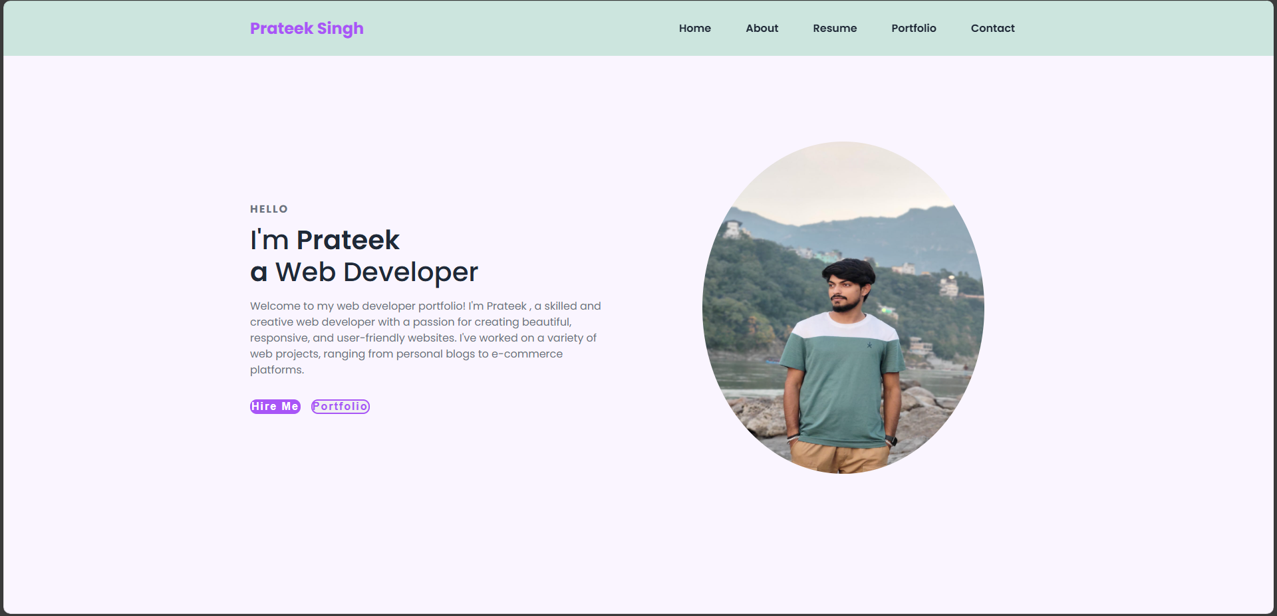

About :

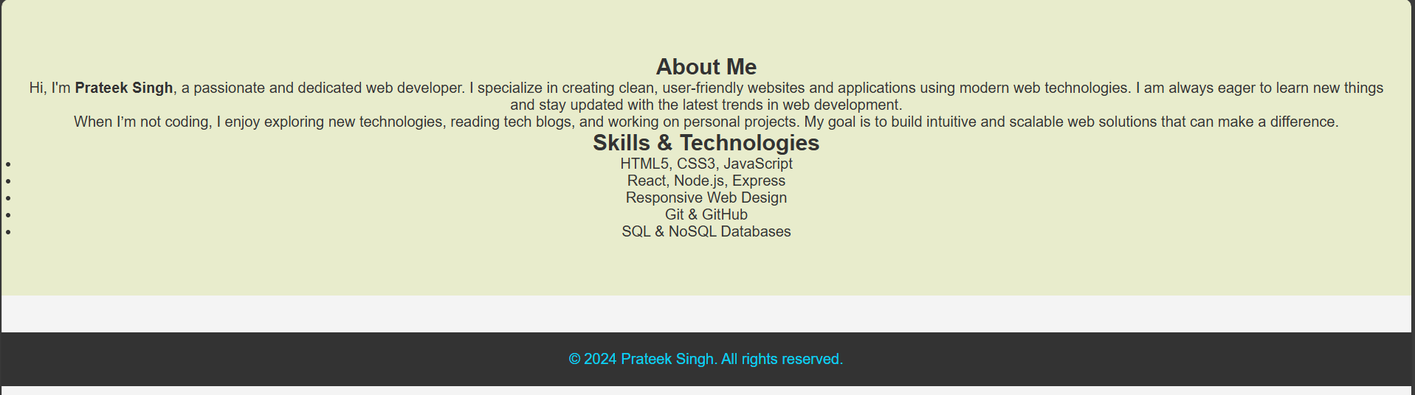

RESUME :

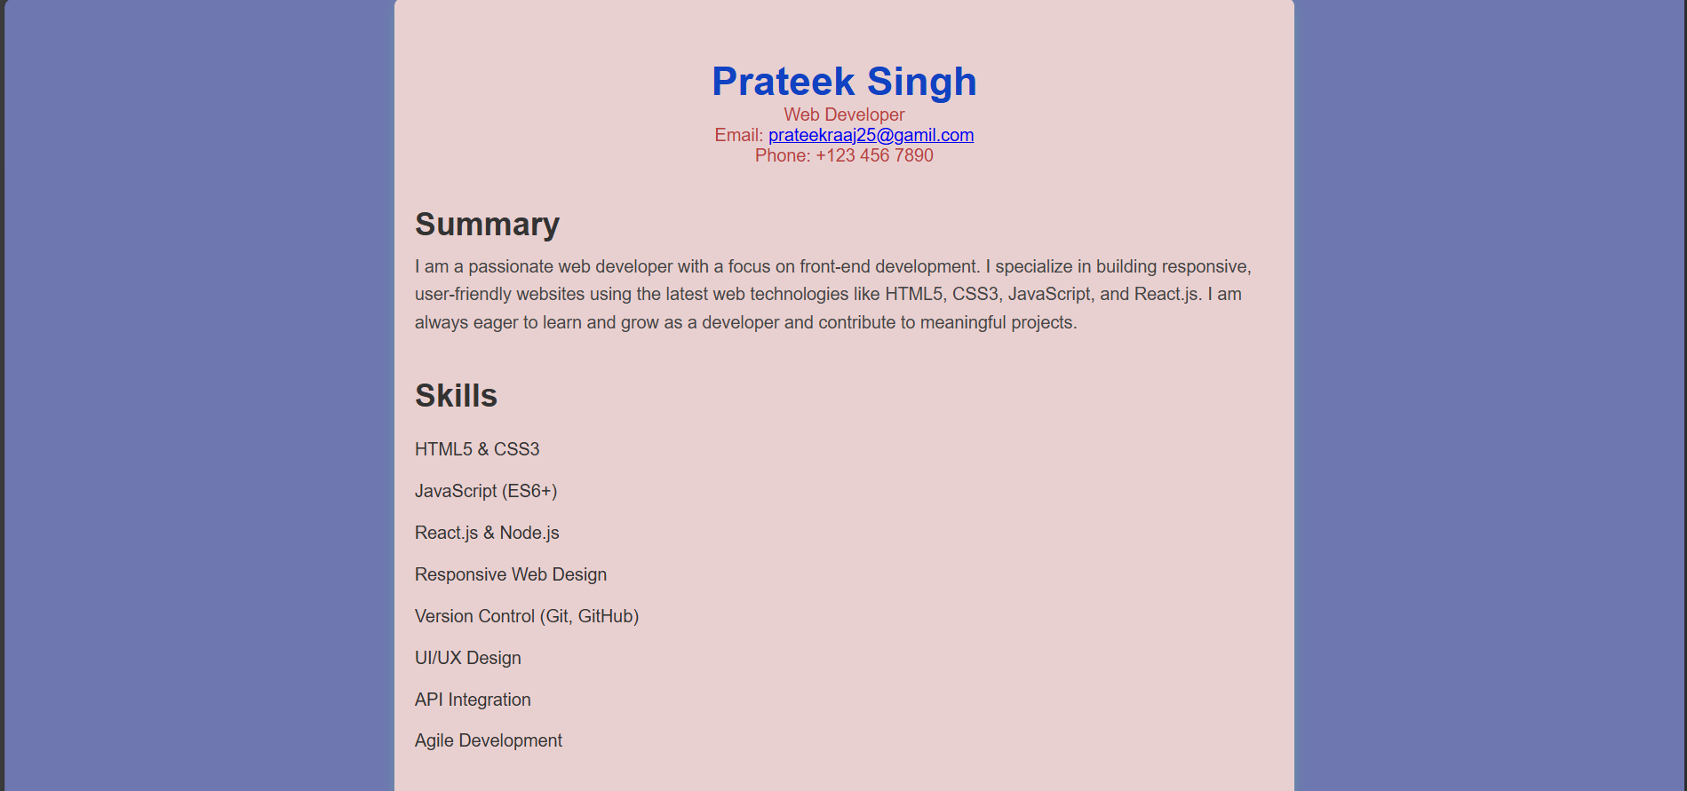

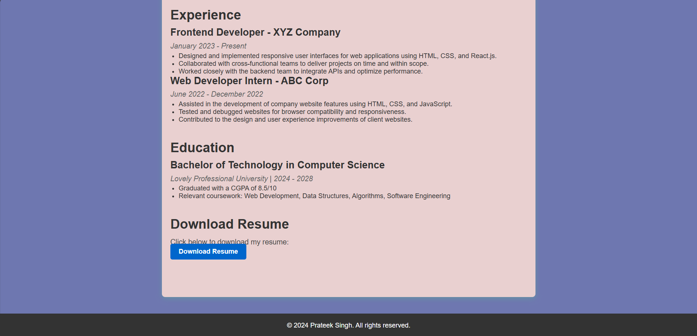

PORTFOLIO :

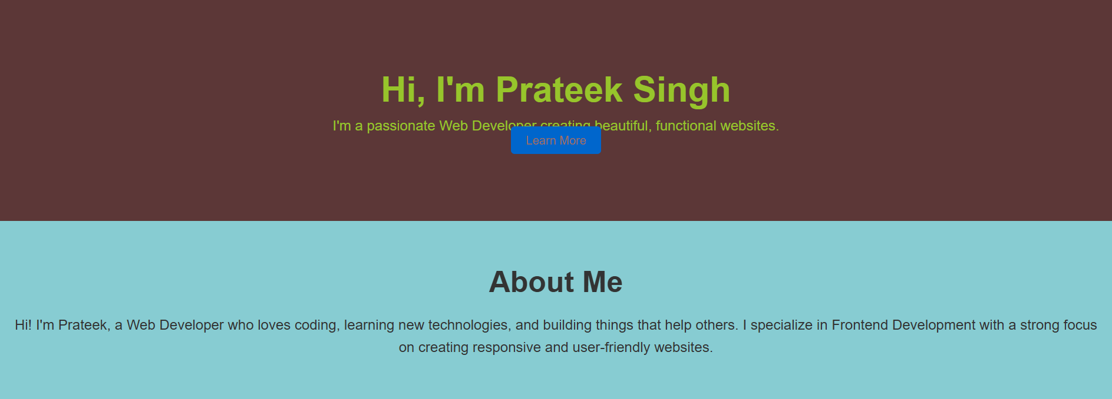

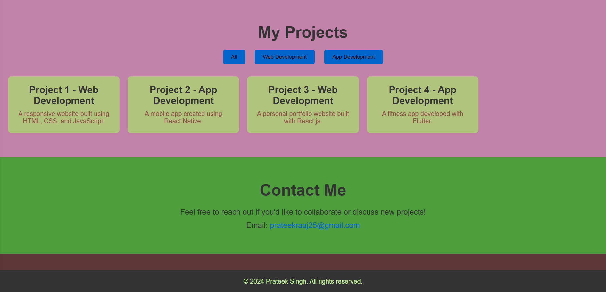

CONTACT :

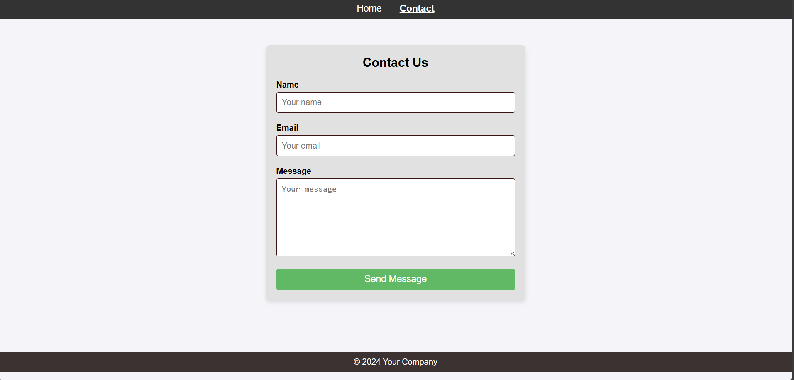

**REFERENCES:**

* ChatGPT.
* Google.